Eco-friendly premium packaging at Packaging Innovations

Neuried, 25 August 2021. New prototypes with eco-friendly finishes from the Better Human project set the stage for the PrintCity Alliance’s return to Packaging Innovations in Warsaw. This project, as well as other products from Alliance members, will also be introduced in the trade fair’s seminar program.

Eco-friendly premium packaging

Packaging must meet the conflicting demands of quality, function and sustainability.
While emphasis in the past was on function and quality, attitudes today have changed and sustainability is increasingly gaining significance.
The entire industry is in a state of change and developing solutions that promote sustainability.
In the process however, it still is crucial to preserve function (product protection!) in full and quality to the greatest possible extent.
The Better Human project demonstrates the current status of these developments.
New prototypes will be on exhibit and introduced in a seminar.

In-person exchanges: Irreplaceable in the packaging industry

“We’re very pleased the trade fair can be held in-person again this year. Although online seminars will continue to be an important part of the overall communication strategy in future, personal interaction with customers and partners is irreplaceable,” says Rainer Kuhn, Print City Alliance Managing Director. “In the packaging industry, the customer experience at the point of sale is a leading issue, so being able to see and handle packaging items is essential.”

The 13th Packaging Innovations event takes place on 15 and 16 September in Warsaw, Poland.
The PrintCity Alliance’s shared booth B26 is centrally located in the trade fair hall.
The seminar on Eco-Friendly Premium Packaging is on 15 September at 10:30 a.m. in the Workshop area.
Visitors receive free admission to the trade fair and seminar when they register: https://packaginginnovations.pl/gb/

Participants at the Alliance’s shared stand B26:

PC Print / LEONHARD KURZ (hot stamping, cold transfer and digital transfer applications, holograms), Merck (special effect pigments), WEILBURGER Graphics (varnishes, adhesives and water-based flexo inks), Zeller+Gmelin (UV inks and coatings)

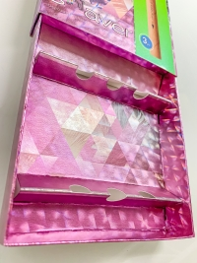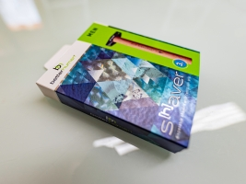

Packaging must meet the conflicting demands of quality, function and sustainability. The entire industry has been in a state of change in recent years and developing solutions that promote sustainability. In the process however, it still is crucial to preserve function (product protection!) in full and quality to the greatest possible extent.
The Better Human project demonstrates the current status of these developments.

Rainer Kuhn, Managing Director PrintCity Alliance
“We’re very pleased the trade fair can be held in-person again this year. Although online seminars will continue to be an important part of the overall communication strategy in future, personal interaction with customers and partners is irreplaceable.”
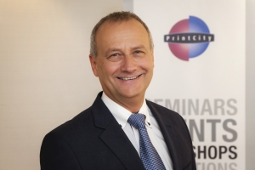

Press photos and press release:

https://www.printcity.de/de/news-reader/items/packaging-innovations-warschau-2021.html
This press release is also available in Polish.

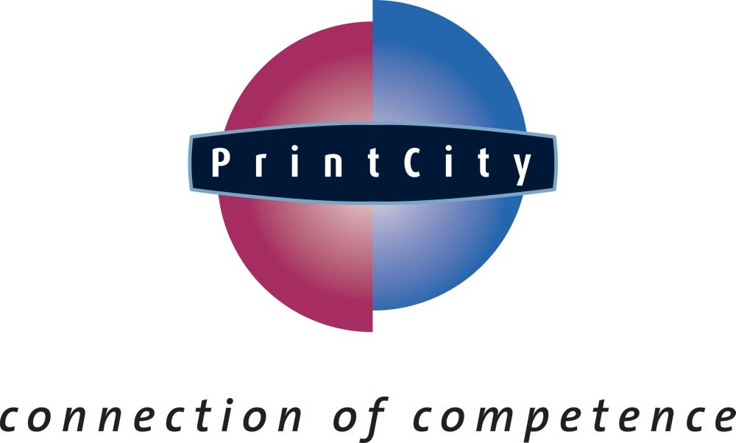
About PrintCity Alliance
PrintCity is a strategic alliance recognised as the “connection of competence” across the entire printing and packaging value chain, promoting the value of print and packaging.

- We deliver value to customers by gathering and sharing leading global know-how within a network.
- We deliver knowledge via seminars, trade fairs, project studies, tutorials, publications and electronic platforms.
- We maximize synergies to develop our industry effectively and cost-efficiently.
PrintCity GmbH & Co. KG, Eichenstrasse 10, D-82061 Neuried, Germany
Tel.: +49 89 749092- 23, Fax: +49 89 749092- 25, E-mail: info@printcity.de, Internet: www.printcity.de
Munich District Court HRA 93911
VAT ID No.: DE222766170
General Partner: PrintCity Verwaltungsgesellschaft mbH / Munich District Court HRB 189908 / Managing Director: Rainer Kuhn
Bank information: HypoVereinsbank München / Sort code 700 202 70 ∙ Acct. No. 667505372 / BIC HYVEDEMM / IBAN DE85700202700667505372

