PrintCity Alliance at virtual drupa

Neuried, 29 March 2021. The PrintCity Alliance will be exhibiting at virtual drupa in April with a focus on premium eco-friendly packaging. This subject is gaining significance worldwide and will be addressed in two web sessions hosted by the Alliance.
Drupa and PrintCity: A partnership with a long tradition
The members of the Alliance met for the first time at drupa in 2000 under the slogan “Connection of Competence”. Since then they have developed a close and productive partnership. Last year, their 20th anniversary celebration at drupa 2020 had to be canceled.
“We’re very pleased drupa is still taking place at least virtually! We hope visitors respond positively to the new online format, and we’re optimistic that the web sessions will be well attended”, says Rainer Kuhn, Managing Director, expressing the aims of the Alliance and its members for the event.
New Better Human samples
The broad-based Better Human project has been extended and continues to demonstrate how environmental goals can be reconciled with highly finished premium packaging. The new samples are again based on a plastic-free design and incorporate sustainable, recyclable products (substrates, inks, varnishes, iriodines, thin layer decorations). They were produced using energy-efficient UV LED technology.
Web sessions: Eco-Friendly Premium Packaging
The two web sessions, both with identical content, will be held on 21 April (8:40 a.m. -9:40 a.m. CET) and 22 April (4:40 p.m. -5:40 p.m. CET) in English. The times were selected to give interested participants from all over the world a chance to attend.
Members participating in virtual drupa:
IST Metz (UV curing systems), LEONHARD KURZ (hot stamping, cold and digital transfer applications, holograms), Metsä Board (premium lightweight folding boxboard, food service paperboard and white kraftliner made from fresh fibre), WEILBURGER Graphics (varnishes, adhesives and water-based flexo inks).
Additionally involved in the Better Human project: KAMA (embossing, cutting, gluing), Merck (special effect pigments), Zeller+Gmelin (UV inks and coatings).
Press photos and press release:
https://www.printcity.de/en/news-reader/items/virtual-drupa-en.html
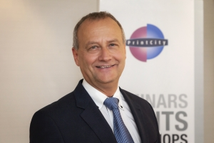
Rainer Kuhn, Managing Director, PrintCity Alliance
“We’re very pleased drupa is still taking place at least virtually! We hope visitors respond positively to the new, online format and we’re optimistic that the web sessions will be well attended.”

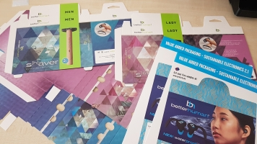
Energy efficient UV LED technology was used for the new samples of the Better Human concept. They are again based on a plastic-free design and incorporate sustainable, recyclable products (substrates, inks, varnishes, iriodines, thin layer decorations).

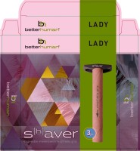

Better Human, the PrintCity Alliance’s broadly based project, demonstrates how premium packaging can be reconciled with the demands of environmental protection and sustainability.

About PrintCity Alliance
PrintCity is a strategic alliance recognised as the “connection of competence” across the entire printing and packaging value chain, promoting the value of print and packaging.

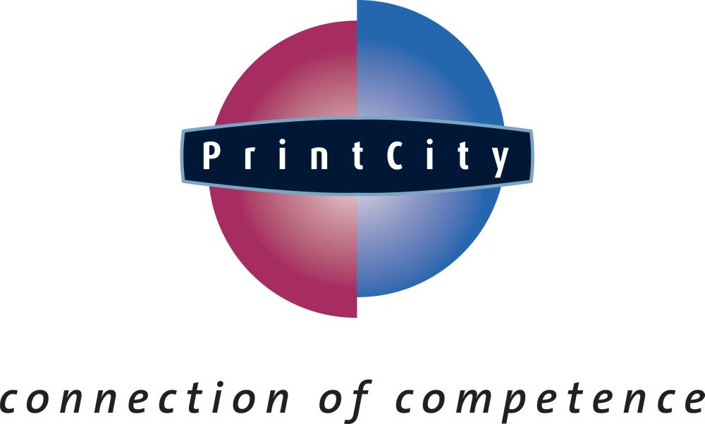

- We deliver value to customers by gathering and sharing leading global know-how within a network.
- We deliver knowledge via seminars, trade fairs, project studies, tutorials, publications and electronic platforms.
- We maximise synergies to develop our industry effectively and cost-efficiently.

PrintCity GmbH & Co. KG, Eichenstrasse 10, D-82061 Neuried, Germany
Tel.: +49 89 749092- 23, Fax: +49 89 749092- 25, E-mail: info@printcity.de, Internet: www.printcity.de
Munich District Court HRA 93911 VAT ID No.: DE222766170
General Partner: PrintCity Verwaltungsgesellschaft mbH / Munich District Court HRB 189908 / Managing Director: Rainer Kuhn
Bank information: HypoVereinsbank München / Sort code 700 202 70 ∙ Acct. No. 667505372 / BIC HYVEDEMM / IBAN DE85700202700667505372

